【原创】driver verifier查找隐藏的内存泄露BUG
verifier是微软提供的驱动测试工具，可以用来识别内存损坏、错误处理的 I/O 请求包 (IRP)、无效的直接内存访问 (DMA) 缓冲区占用、可能的死锁以及低资源模拟等情况。在开始菜单->运行中输入 verifier后，可以弹出如下菜单：
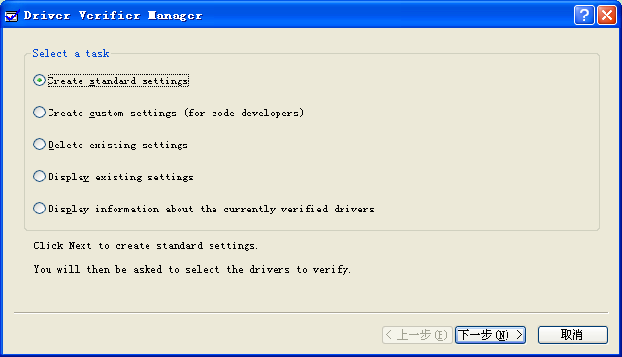

选择默认选项Create standard settings并点击下一步后，出现如下菜单：
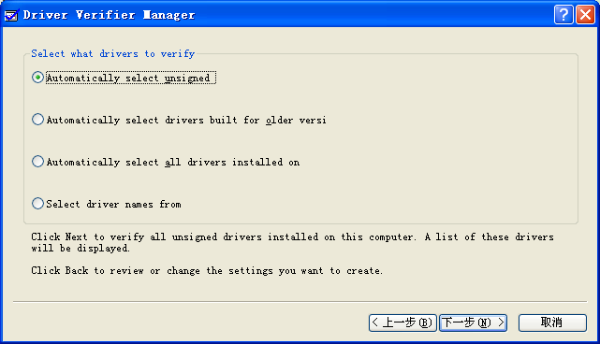

选择Automatically select unsigned 并点击下一步后，出现可进行检查的驱动：
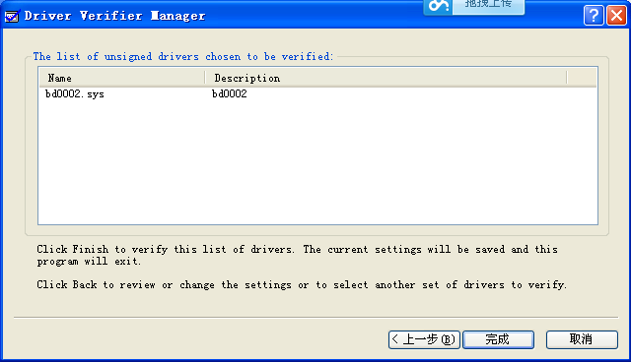
点击完成按钮，并重启后verifier便对驱动进行检查。也可以配置verifier对驱动进行更详细地检查(选择Create custom settings->Select individual settings from a full list):
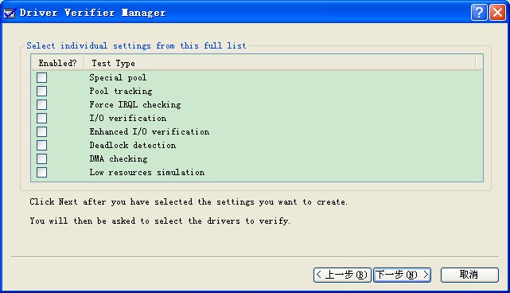

本文要介绍的是使用verifier对驱动内存泄露的检查。做法比较简单，加载驱动并挂verifier后，卸载驱动，若没蓝屏说明驱动没有内存泄露，蓝屏了说明有内存泄露。
测试代码在DriverEntry中申请一块内存并且不做释放，代码如下：
NTSTATUS DriverEntry(PDRIVER_OBJECT DriverObject, PUNICODE_STRING RegistryString)
{
NTSTATUS Status = STATUS_SUCCESS;
UNICODE_STRING ustrLinkName;
UNICODE_STRING ustrDevName;
PDEVICE_OBJECT DeviceObject;
PVOID pTest;

pTest = ExAllocatePoolWithTag(NonPagedPool, 2000, 'a');

DbgPrint("[ObCallback] DriverEntry: %wZ\n",RegistryString);
// Create dispatch points for device control, create, close.
DriverObject->MajorFunction[IRP_MJ_CREATE] = DispatchCreate;
DriverObject->MajorFunction[IRP_MJ_READ] = DispatchRead;
DriverObject->MajorFunction[IRP_MJ_CLOSE] = DispatchClose;
DriverObject->MajorFunction[IRP_MJ_DEVICE_CONTROL] = DispatchIoctl;
DriverObject->DriverUnload = DriverUnload;
//
RtlInitUnicodeString(&ustrDevName, DEVICE_NAME);
Status = IoCreateDevice(DriverObject,
0,
&ustrDevName,
FILE_DEVICE_UNKNOWN,
0,
FALSE,
&DeviceObject
);
DbgPrint("[ObCallback] Device Name: %wZ\n",&ustrDevName);

if(!NT_SUCCESS(Status)){
DbgPrint("[ObCallback] IoCreateDevice = 0x%x\n", Status);
return Status;
}
RtlInitUnicodeString(&ustrLinkName, LINK_NAME);
Status = IoCreateSymbolicLink(&ustrLinkName, &ustrDevName);
if(!NT_SUCCESS(Status)){
DbgPrint("[ObCallback] IoCreateSymbolicLink = 0x%x\n", Status);
IoDeleteDevice(DeviceObject);
return Status;
}
DeviceObject->Flags |= DO_BUFFERED_IO;
DbgPrint("[ObCallback] SymbolicLink: %wZ\n",&ustrLinkName);
return STATUS_SUCCESS;
}

编译生成文件后，并在verifier中选择此驱动并重启：
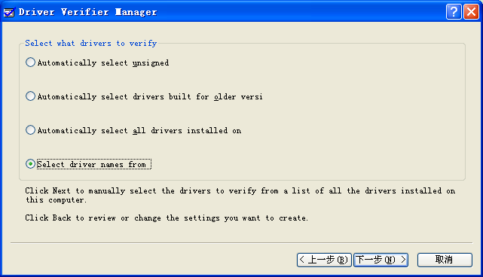
然后用驱动加载工具加载此驱动，并点击安装、启动按钮，随后点击卸载按钮后，果然蓝屏了：
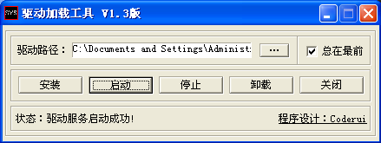

Windbg.exe加载此蓝屏dump，信息如下:

kd> !analyze -v
*******************************************************************************
* *
* Bugcheck Analysis *
* *
*******************************************************************************

DRIVER_VERIFIER_DETECTED_VIOLATION (c4)
A device driver attempting to corrupt the system has been caught. This is
because the driver was specified in the registry as being suspect (by the
administrator) and the kernel has enabled substantial checking of this driver.
If the driver attempts to corrupt the system, bugchecks 0xC4, 0xC1 and 0xA will
be among the most commonly seen crashes.
Arguments:
Arg1: 00000060, A driver has forgotten to free its pool allocations prior to unloading.
Arg2: 00000000, paged bytes
Arg3: 000007d0, nonpaged bytes,
Arg4: 00000001, total # of (paged+nonpaged) allocations that weren't freed.
To get the name of the driver at fault, type
dp ViBadDriver l1; dS @$p
Then type !verifier 3 drivername.sys for info on the allocations
that were leaked that caused the bugcheck.

Debugging Details:
------------------
Unable to map view of image file
BUGCHECK_STR: 0xc4_60
IMAGE_NAME: ObCallback.sys
DEBUG_FLR_IMAGE_TIMESTAMP: 53578229
MODULE_NAME: ObCallback
FAULTING_MODULE: f885f000 ObCallback
DEFAULT_BUCKET_ID: DRIVER_FAULT
PROCESS_NAME: services.exe
LAST_CONTROL_TRANSFER: from 80650d0c to 804f9cdb

STACK_TEXT:
ef52cacc 80650d0c 000000c4 00000060 00000000 nt!KeBugCheckEx+0x1b
ef52caf4 805a45b5 819ce270 81d2b740 81d2b768 nt!MiVerifyingDriverUnloading+0x12a
ef52cb20 80579c88 819ce270 81d2b750 ef52cb4c nt!MmUnloadSystemImage+0x183
ef52cb30 805b1cf4 81d2b768 81d2b750 00000000 nt!IopDeleteDriver+0x32
ef52cb4c 80523cb5 81d2b768 00000000 ef52cc30 nt!ObpRemoveObjectRoutine+0xe0
ef52cb70 804f57c2 ef52cc30 ef52ccac efc94902 nt!ObfDereferenceObject+0x5f
ef52cc14 8057a937 ef52cd0c 00000000 ef52cc30 nt!IopUnloadDriver+0x28a
ef52cc24 8053e854 ef52cd0c ef52cd48 80500255 nt!NtUnloadDriver+0xf
ef52cc24 80500255 ef52cd0c ef52cd48 80500255 nt!KiSystemServicePostCall
ef52cca0 804f5629 ef52cd0c ef52cd64 00d3f868 nt!ZwUnloadDriver+0x11
ef52cd48 8057a937 00d3f870 00000000 ef52cd64 nt!IopUnloadDriver+0xf1
ef52cd58 8053e854 00d3f870 00d3f878 7c92e514 nt!NtUnloadDriver+0xf
ef52cd58 7c92e514 00d3f870 00d3f878 7c92e514 nt!KiSystemServicePostCall
WARNING: Frame IP not in any known module. Following frames may be wrong.
00d3f878 00000000 00000000 00000000 00000000 0x7c92e514

STACK_COMMAND: kb
FOLLOWUP_NAME: MachineOwner
FAILURE_BUCKET_ID: 0xc4_60_VRF_IMAGE_ObCallback.sys_RECENT
BUCKET_ID: 0xc4_60_VRF_IMAGE_ObCallback.sys_RECENT
Followup: MachineOwner

键入!verifier 3 ObCallback.sys命令:
kd> !verifier 3 ObCallback.sys
Verify Level ff ... enabled options are:
Special pool
Special irql
Inject random low-resource API failures
All pool allocations checked on unload
Io subsystem checking enabled
Deadlock detection enabled
Enhanced Io checking enabled
DMA checking enabled

Summary of All Verifier Statistics

RaiseIrqls 0x0
AcquireSpinLocks 0x0
Synch Executions 0x0
Trims 0x0

Pool Allocations Attempted 0x1
Pool Allocations Succeeded 0x1
Pool Allocations Succeeded SpecialPool 0x1
Pool Allocations With NO TAG 0x0
Pool Allocations Failed 0x0
Resource Allocations Failed Deliberately 0x0

Current paged pool allocations 0x0 for 00000000 bytes
Peak paged pool allocations 0x0 for 00000000 bytes
Current nonpaged pool allocations 0x1 for 000007D0 bytes
Peak nonpaged pool allocations 0x1 for 000007D0 bytes

Driver Verification List

Entry State NonPagedPool PagedPool Module

81f95f00 Loaded 000007d0 00000000 ObCallback.sys

Current Pool Allocations 00000001 00000000
Current Pool Bytes 000007d0 00000000
Peak Pool Allocations 00000001 00000000
Peak Pool Bytes 000007d0 00000000

PoolAddress SizeInBytes Tag CallersAddress
829e0830 0x000007d0 a... f8860129

f8860129便是内存泄露地址的下一句汇编地址，反汇编上一句(call调用)汇编地址：
kd> u f8860129-6
ObCallback+0x1123:
f8860123 ff151c1086f8 call dword ptr [ObCallback+0x201c (f886101c)]
f8860129 ff750c push dword ptr [ebp+0Ch]
f886012c 68420386f8 push offset ObCallback+0x1342 (f8860342)
f8860131 e8d2000000 call ObCallback+0x1208 (f8860208)
f8860136 8b7508 mov esi,dword ptr [ebp+8]
f8860139 8b3d0c1086f8 mov edi,dword ptr [ObCallback+0x200c (f886100c)]
f886013f 59 pop ecx
f8860140 59 pop ecx
kd>
ObCallback+0x1123:
f8860123 ff151c1086f8 call dword ptr [ObCallback+0x201c (f886101c)]
f8860129 ff750c push dword ptr [ebp+0Ch]
f886012c 68420386f8 push offset ObCallback+0x1342 (f8860342)
f8860131 e8d2000000 call ObCallback+0x1208 (f8860208)
f8860136 8b7508 mov esi,dword ptr [ebp+8]
f8860139 8b3d0c1086f8 mov edi,dword ptr [ObCallback+0x200c (f886100c)]
f886013f 59 pop ecx
f8860140 59 pop ecx

f8860123地址处便是内存泄露的地方。查看call dword ptr [ObCallback+0x201c (f886101c)]中的f886101c的内容，并反汇编：
kd> dd f886101c l1
f886101c 80651a68
kd> u 80651a68
nt!VerifierAllocatePoolWithTag:
80651a68 8bff mov edi,edi
80651a6a 55 push ebp
80651a6b 8bec mov ebp,esp
80651a6d 51 push ecx
80651a6e 51 push ecx
80651a6f 8d45f8 lea eax,[ebp-8]
80651a72 50 push eax
80651a73 8d45fc lea eax,[ebp-4]

对应的函数是VerifierAllocatePoolWithTag，源代码其实是ExAllocatePoolWithTag。因为driver verifier Hook了驱动的输入表，把ExAllocatePoolWithTag函数替换为verifier 的VerifierAllocatePoolWithTag函数。
这样就找到了导致内存泄露的地方。

Web：http://bbs.pediy.com/showthread.php?t=186922

